Regulatory Processing
Digital Client Onboarding

Version: 1.0
Date Last Published: November 27, 2020
Author(s): Roland Matsuba, Lorraine McLeod, Candyse Watkinson


ts

Contents
Document Information 3
1. Revision History 3
2. Related Document References 3
Problem Statement 4
Discovery 4
Requested Information 5
Identify Manual Creation by Name/Folders 5
Scenarios for IDV Verification and Matching Criteria 6
Criteria for Checking 9
Manual Input Fields 10
Recommendations 11

Document Information

Revision History
Version | Date | Authors | Revision Notes
1.0 | 13 November 2020 | Roland Matsuba | Initial Version
1.0 | 27th November | Lorraine McLeod | Minor edit

Related Document References
Ref | Document Name | Short Description and URL
R1 | DCO Decision Criteria for Checks | A matrix used to identify the decision criteria for the different checks including Enstream, Thirdstream, AML Compliance, Fraud, Flinks and Credit Bureau.  DCO Decision Criteria for Checks

Problem Statement
Regulatory Processing are having issues identifying where there is manual intervention and the fields that were inputted manually in the DCO process as well as locating files in FileNet that were manually uploaded.
Regulatory Processing want to be able to identify where there were any manual intervention and which fields were inputted manually. They also require the ability to access manually uploaded identification documents and be provided an understanding of the field selections available for manual inputs in Workspaces.

Discovery
- The Digital team has identified a process gap for manual document uploads
  - When an account has been created manually in T24, staff sometimes use the Outlook folder widget and enter in the CIF number then upload the documents. The documents are added to the CIF that the staff member entered that they had already created in T24. This is the old process, pre-Motive DCO.
  - If however, in Motive DCO, an ID document is received via email and the Outlook process is used, this is can result in issues in Journey Manager and FileNet.
  - Using Workspaces to upload emailed documents is the usual and recommended method.
- Information Services is looking into ways to identify manually decisioned applications and channel them to a specific folder in FileNet.
- The Digital team has worked with our partners to document the criteria used for checks for ID verification.
- For applications with manual intervention from the Motive Team, Regulatory Processing is required to review all inputs related to AML (Anti Money Laundering)/KYC (Know Your Customer). The review includes the CIF related fields (ID, Address, NOC, PEP, Employer Information) and Account Related Fields (Intended Use and Third Party determination).
  - An issue was identified regarding when Motive staff manually input data into Workspaces as part of their manual review process, the DCO tool is essentially still opening the CIF/Account. Therefore in T24, the User ID will be MOT.DIG. In this scenario, there is no way to know that Motive staff had manually entered the information.
- For happy path CIFs/accounts, all fields are validated before the CIF/account are created in T24.
  - Any applications (CIF and Account) that are decisioned need to be reviewed (Only AML related fields (first/last name, address, Date of Birth, Employment Details (Occupation description and NOC, Third Party determination and Intended Use)
- Regulatory Processing are having difficulties locating files in FileNet, however it has been identified that the main issue was that the information was not in FileNet due to manual steps completed in outlook, which also created issues in Journey Manager. Documents uploaded via the previous outlook method were left behind in Journey Manager after an application was approved.
  - Information Services has now completed a cleanup task in Journey Manager that will make locating documents easier in FileNet and streamline the process.

Requested Information

Identify Manual Creation by Name/Folders
Within FileNet, there are a few ways to identify if CIFs are fully automated via DCO and/or started via DCO and required manual intervention and approval in workspaces.
- Files
  - DCO created – a file named Datamodel.xml is created

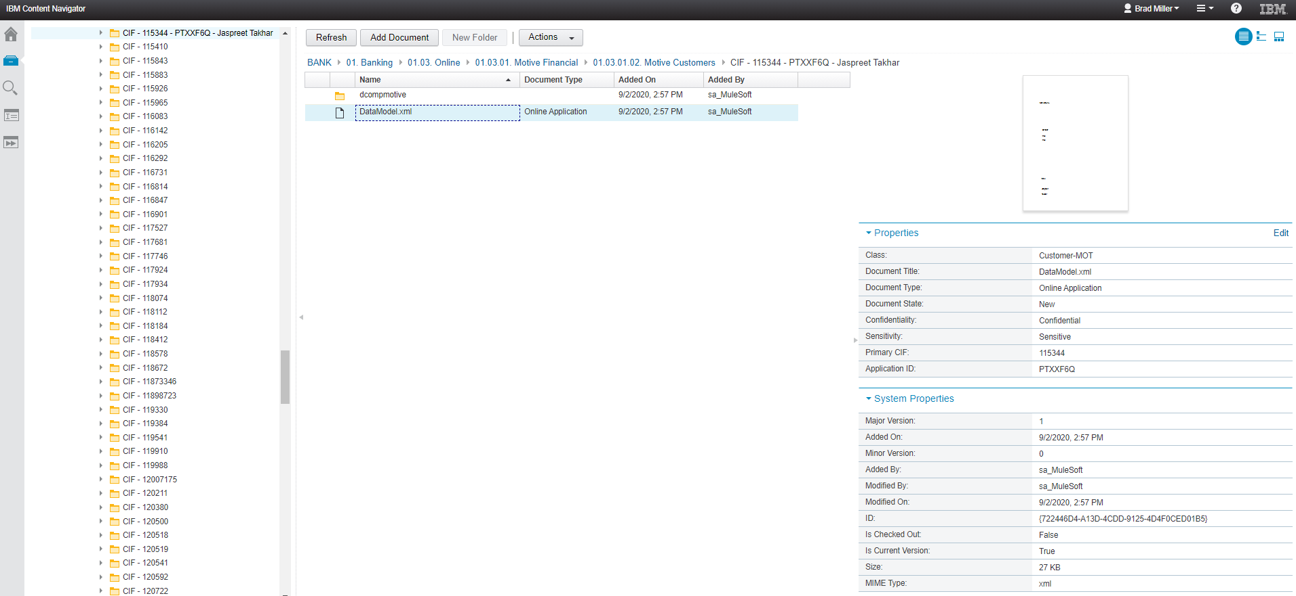
- Folders
Old FileNet Folder Structure
  - DCO created - Folders that have an application ID and a name
  - Manually created in T24 - When there is only a CIF number on the folder, this indicates the account was created manually in T24 and documents were uploaded using the Outlook widget.

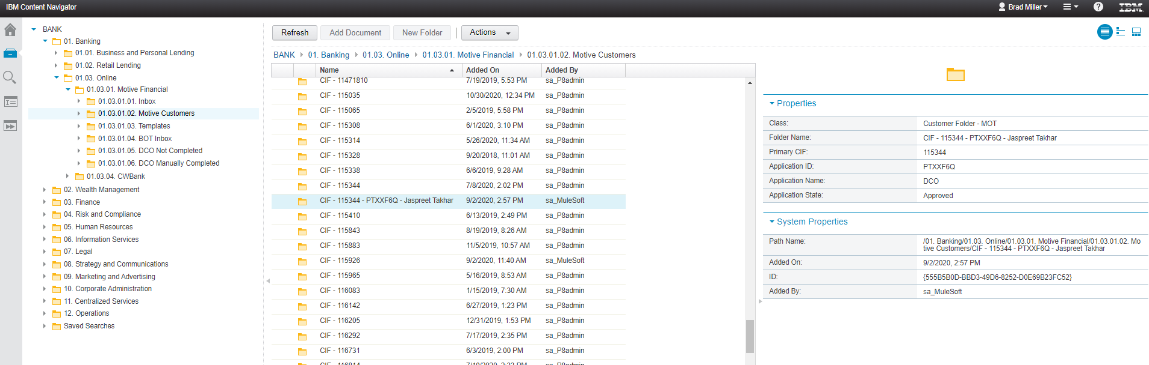

New FileNet Folder Structure
The new FileNet folder structure is broken down into Motive Financial, CWBank. Under CWBank, it is further broken down into CWB Personal DCO and CWB Personal In-Branch DCO. Under each of these folders, there will be a Manually Completed folder that contains all of the applications that were manually completed. When the ReviewedBy property is populated, a CWB employee has manually intervened in the application. These applications will be placed in the Manually Completed folder.
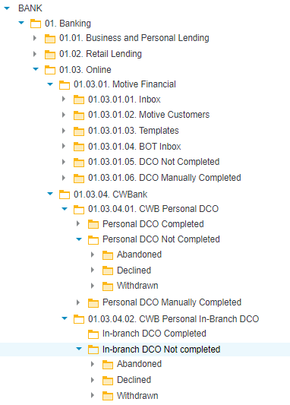
Manually searching through the FileNet folder structure to find applications or CIFs is time consuming and not very user friendly. Information Services has written a number of commonly used queries that will allow users to easily search through the folder structure for specific applications using already defined criteria.
Following is a list of some of the existing queries to use:
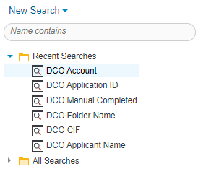

Scenarios for IDV Verification and Matching Criteria
If IDV is completed/verified via DCO
Scenario 1: EQUIFAX AS SINGLE SOURCE OF VERIFICATION
If Equifax report – Name, Date of Birth, Address match (and Credit Bureau is opened more than 3 years):
T24 Field | Value sent to T24 | From where?
Identification.1 | 2 Sets of Identification Mandatory | Multi value this field
Face-To-Face.1 | No | To be defaulted by Avoka
Agent/Affiliate.1 | No | To be defaulted by Avoka
ID Type.1 | ZCFTHREEYR | To be defaulted by Avoka
ID Number.1 | Equifax Report ID | From Equifax report
Source of Information.1 | Equifax | To be defaulted by Avoka
Matching Criteria.1 | DCO VALIDATED | To be defaulted by Avoka
Country of Issue.1 | CA | To be defaulted by Avoka
Place of Issue/Jurisdiction.1 | Equifax | To be defaulted by Avoka
Employee Verification Date.1 | YYYYMMDD | No physical ID will be verified - Default to Application date
Identification.2 | 2 Sets of Identification Mandatory | Multi value this field
Face-To-Face.2 | No | To be defaulted by Avoka
Agent/Affiliate.2 | No | To be defaulted by Avoka
ID Type.2 | ZEXEMPT | To be defaulted by Avoka
ID Number.2 | Equifax Report ID | From Equifax report
Source of Information.2 | Equifax | To be defaulted by Avoka
Matching Criteria.2 | DCO VALIDATED | To be defaulted by Avoka
Country of Issue.2 | CA | To be defaulted by Avoka
Place of Issue/Jurisdiction.2 | Equifax | To be defaulted by Avoka
Employee Verification Date.2 | YYYYMMDD | No physical ID will be verified - Default to Application date

Scenario 2: EQUIFAX AS ONE SOURCE IN A DUAL SOURCE VERIFICATION
If on Equifax report - Partial Match on Name, DOB, and Address (2 of 3 values) or Equifax is more than 6 Months but less than 3 years:
T24 Field | Value sent to T24 | From where?
Identification.1 | 2 Sets of Identification Mandatory | Multi value this field
Face-To-Face.1 | No | To be defaulted by Avoka
Agent/Affiliate.1 | No | To be defaulted by Avoka
ID Type.1 | ZCFSIXMNTH | To be defaulted by Avoka
ID Number.1 | Equifax Report ID | From Equifax report
Source of Information.1 | Equifax | To be defaulted by Avoka
Matching Criteria.1 | DCO VALIDATED | To be defaulted by Avoka
Country of Issue.1 | CA | To be defaulted by Avoka
Place of Issue/Jurisdiction.1 | Equifax | To be defaulted by Avoka
Employee Verification Date.1 | YYYYMMDD | No physical ID will be verified - Default to Application date
Identification.2 | 2 Sets of Identification Mandatory | Multi value this field
Face-To-Face.2 | No | To be defaulted by Avoka
Agent/Affiliate.2 | No | To be defaulted by Avoka
ID Type.2 | ZCADFIN or ZENTDOC | To be defaulted by Avoka
ID Number.2 | FI Account Number/Vendor Account | From document provided
Source of Information.2 | Flinks or Enstream | To be defaulted by Avoka
Matching Criteria.2 | DCO VALIDATED | To be defaulted by Avoka
Country of Issue.2 | CA | To be defaulted by Avoka
Place of Issue/Jurisdiction.2 | Flinks or Enstream | To be defaulted by Avoka
Employee Verification Date.2 | YYYYMMDD | No physical ID will be verified - Default to Application date

Scenario 3: DUAL SOURCE VERIFICATION WITHOUT EQUIFAX
If no match on Equifax
T24 Field | Value sent to T24 | From where?
Identification.1 | 2 Sets of Identification Mandatory | Multi value this field
Face-To-Face.1 | No | To be defaulted by Avoka
Agent/Affiliate.1 | No | To be defaulted by Avoka
ID Type.1 | ZCADFIN | To be defaulted by Avoka
ID Number.1 | External Account Number | From Flinks report
Source of Information.1 | Flinks | To be defaulted by Avoka
Matching Criteria.1 | DCO VALIDATED | To be defaulted by Avoka
Country of Issue.1 | CA | To be defaulted by Avoka
Place of Issue/Jurisdiction.1 | Flicks | To be defaulted by Avoka
Employee Verification Date.1 | YYYYMMDD | No physical ID will be verified - Default to Application date
Identification.2 | 2 Sets of Identification Mandatory | Multi value this field
Face-To-Face.2 | No | To be defaulted by Avoka
Agent/Affiliate.2 | No | To be defaulted by Avoka
ID Type.2 | ZENTDOC | To be defaulted by Avoka
ID Number.2 | Vendor Account Number | From document provided
Source of Information.2 | Enstream | To be defaulted by Avoka
Matching Criteria.2 | DCO VALIDATED | To be defaulted by Avoka
Country of Issue.2 | CA | To be defaulted by Avoka
Place of Issue/Jurisdiction.2 | Flinks or Enstream | To be defaulted by Avoka
Employee Verification Date.2 | YYYYMMDD | No physical ID will be verified - Default to Application date

If IDV fails because one of the above can not be achieved, then the application goes into manual review.
Motive collects the applicable non-face-to-face ID documents and manually inputs the information into workspaces and the application can continue.
If manually input:
T24 Field | Value sent to T24 | From where?
Identification.1 | 2 Sets of Identification Mandatory | Multi value this field
Face-To-Face | No | To be defaulted by Avoka
Agent/Affiliate | No | To be defaulted by Avoka
ID Type | Manual input of ID Type provided to Motive | Document provided
ID Number | Manual input of account number etc. from Doc Provided | From document provided
Source of Information | I assume this defaults based on what is input in Place of Issue/Jurisdiction | To be defaulted by Avoka
Matching Criteria | DCO VALIDATED | To be defaulted by Avoka
Country of Issue | CA | To be defaulted by Avoka
Place of Issue/Jurisdiction | Manual input | Document provided
Employee Verification Date | YYYYMMDD | No physical ID will be verified - Default to Application date

Criteria for Checking
AML Assist Criteria
AML Assist | Criteria to Determine Result | Criteria Checking
Full Match | Credit file 36 months or more OR 6 months or older and dual trade lines | Match on name (first and last), full address, Date of Birth
No Hit | Could not find a record OR credit file is less than 6 months old | Not a match on name (first and last), full address, Date of Birth
Partial Match | Credit file 6 months or older OR 6 months or older and single trade lines | Match on name (first and last), full address, Date of Birth

IDV Logic
AML Assist | Enstream | Expected Match Result | Expected Decision | Alternate IDV
Full Match | Full Match | MATCH | APPROVED | Not Required
No Hit | No Hit | NO_MATCH | DECLINED | Required
Full Match | No Hit | MATCH  *Result will be translated to a PARTIAL | REVIEW | Required
No Hit | Full Match | PARTIAL | REVIEW | Required
Partial Match | No Hit | PARTIAL | REVIEW | Required
Full Match | Partial Match | MATCH | APPROVED | Not Required
No Hit | Partial Match | NO_MATCH | DECLINED | Required

Manual Input Fields
Motive have access to the following 3 fields for manual input:
- ID type
  - The following values are available:
    - ZCADFIN (NF2F-Canadian Financial Entity)
    - ZCADGOVDOC (NF2F – CND Government Issued Doc)
    - ZCFSIXMNTH (NF2F – CND Credit File Method >= 6 MTh.)
    - ZCFTHREEYR (NF2F – CND Credit File Method >- 3 yr.)
    - ZENTDOC (NF2F – Reliable Private Enterprise Doc)
    - ZEXEMPT (NF2F – Exempt per Policy)
- Place of Issue/Jurisdiction
- ID Number

Recommendations
- Upload all documents for DCO through Workspaces so that the folders and pertinent information are stored correctly in FileNet. Do not use the Outlook widget for DCO applications.
- The Journey Manager clean-up performed by Information Services will address the issue of odd documents in Journey Manager. This will make locating documents easier in FileNet and streamline the process.
- Information Services has created a flag ReviewedBy to identify applications that had any manual intervention so these can be included in the monthly BI report. Regulatory Processing need to request a change from BI to modify their existing BI Report to only display the applications with the ReviewedBy flag set to ‘TRUE’.
- At this time, Regulatory Processing will not be added to Workspaces to review applications for AML before an application is approved.
  - There is a threshold for AML deficiencies of 5%. Currently Motive DCO are below this threshold.
  - Regulatory Processing to track any deficiencies seen in their reports for DCO only applications starting October 1st, 2020.
  - This will be revisited if deficiencies rise above the threshold.

